

v. 190403

# ****instructions manual for vibratory linear feeder TYPe - PL 1, PL 2, PL 3.****

|  |  |
| --- | --- |
|  |  |

## [www.wibramet.](http://www.wibramet.net)pl

## e-mail: info@wibramet.pl

## Tel. (094) 345-75-00, tel.kom. 782-972-268

## 75-736 Koszalin

## ul. Gnieźnieńska 68

## manufacturing no. 6171/24

# 1. intended use

Vibratory linear feeder is intended for lengthen feeding line of orientated, in bowl feeders, components. Field of use: automatic assembly, packing, controlling, machining stations, transport of loose materials.

The vibratory feeder is an integral part of the stands.

The device operates in normal ambient conditions within temperature range from +5 to +35˚C.

# 2. Warnings

**2.1** Do not connect the feeder to the power supply network without proper supplying controller provided for this purpose.

**2.2** Do not pour any liquid on the feeder during its cleaning.

**2.3** Any maintenance and repair operations should be done only if the power supply plug is taken out from the power supply network socket.

**2.4** Do not operate the feeder before it is set on rubber shock absorbers (6) located in the base.

**2.5** Do not used feeders in any explosive atmosphere.

**2.6** Do not use feeder without electromagnet cover (3).

**2.7** The electromagnetic field! People with fitted cardiac pacemakers have to keep distance of 0,5 meters from the vibratory feeder.

# 3. design description

Vibratory linear feeder consist of following parts:

Feeder is equipped with set of flat springs (made from steel or plastic) and electromagnet with regulated gap.

Electronic controllers with step-less feed speed control are supplied in various versions depending on individual arrangements made with the customer.

Feeder is equipped in 4 pieces of absorber.

Feeder need to be mount to device by holes into bottom of absorber.

# 4. technical data

For standard feeder technical parameters see table no. 1.

Feeder in standard version doesn’t have guide rail.

# 5. Mounting of guide rail

To mount guide rail use 4 treaded holes in aluminium support plate (2).

Structure of rail should be light and stiff.

Mass of rail shouldn’t exceed the maximum – see table 1.

Recommended dimensions of rail behind and in front of aluminium support plate (2) are marked in drawing.

It is good to lean the feeder by angle 3 to 4˚ to outlet.

# 6. feeder starting

Feeder is supplied with controller.

To start feeder please insert controller plug into electrical socket 230V/50Hz.

Press the start button and set transmission performance by knob.

# 7. controllers

Supply the feeders only from controllers intended for cooperation with vibratory feeders.

Preferred controllers are delivered with the feeder.

The controllers delivered may possess extensive functional options described in the manufacturer’s instructions.

The frequency of supply vibrating feeder must be adjust to frequency of mechanical vibrations for each feeder type (see tab.1).

# 8. maintance

Linear feeder hasn’t got any lubrication points and doesn’t’ t require any special maintaining operations during exploitation.

In the event of occurrence of noise exceeding 70dB (without any elements in the guide rail) or reduction of speed, please check:

* Size of „S” electromagnet operating gap (for recommended gap to be applied in given feeder type – see Table 1 Technical Data).
* Flat springs (5) fixing.
* Flat springs (5) condition – replace any broken spring.
* Guide rail fixing.
* Electromagnet cover fixing.
* Is feeder blocked by direct touch with any other device.

# 9. storage and transport

Transport the feeder on board any covered means of transport.

Linear feeder please transport packed in box.

Keep the feeders in closed rooms to protected them against influence of weather conditions.

Ambient temperature: +5 to +35°C.

# 10. list of drAWINGS AND DOCUMENTS ATTACHED

* **Drawing 1** – feeder type PL 1.
* **Drawing 2** – feeder type PL 2.
* **Drawing 3** – feeder type PL 3.
* **Table 1** – standard technical parameters.
* **Table 2** – list of important parts.
* Wiring diagram.
* EC Declaration of Conformity.

# 11. service provided by

**„WIBRAMET Piotr Sokołowski** ”

75-736 Koszalin st. Gnieźnieńska 68.

POLAND

Tel./fax. (094) 345- 75- 00

www.wibramet.pl

e-mail:info@wibramet.pl

## **Tab.1.** standard technical parameters.

|  |  |  |  |  |
| --- | --- | --- | --- | --- |
| ****Characteristics**** | ****Unit**** | ****PL 1**** | ****PL 2**** | ****PL 3**** |
| Mass (without guide rail) | kg | 2 | 5 | 22 |
| Quantity | m/min | 0 - 3 | 0 - 6 | 0 - 6 |
| Guide rail length | mm | 140-200 | 250 - 500 | 350 - 800 |
| Optimum guide rail mass | kg | 0,2 - 0,7 | 1,0 - 2,0 | 2,0 - 8,0 |
| Power supply | V/Hz | 230/50 | 230/50 | 230/50 |
| Absorbers (46°Sh) | mm | Ø15 | Ø15 | Ø30 |
| Flat springs | ≠ mm | 1,5 | 1,5 | 3 |
| Mounting to table | - | 4 x M4 | 4 x M4 | 4 x M8 |
| Mounting of guide rail or hopper | - | 4szt. M5 | 4szt. M5 | 4szt. M8 |
| Operating gap S | mm | 0,3 | 0,7 | 0,8 |
| Bolts to regulate operating gap | - | 2 pcs M4 | 2 pcs M5 | 2 pcs M8 |
| Power max. | VA | 12 | 25 | 90 |
| Vibrating frequency | 1/min | 6000 | 6000 | 3000 |

## **Tab.2.** Important parts list.

|  |  |  |
| --- | --- | --- |
| Drawing pos. | Name | Qty. |
| 1. | Lower support | 1 |
| 2. | Upper support | 1 |
| 3. | Cover | 2 |
| 4. | Electromagnet | 1 |
| 4.1 | Core | 1 |
| 4.2 | Dowel | 1 |
| 5. | Flat spring | 6 |
| 6. | Absorber | 4 |
| 7. | Bolt to regulate | 2 |
| 8. | Weight | 1 |

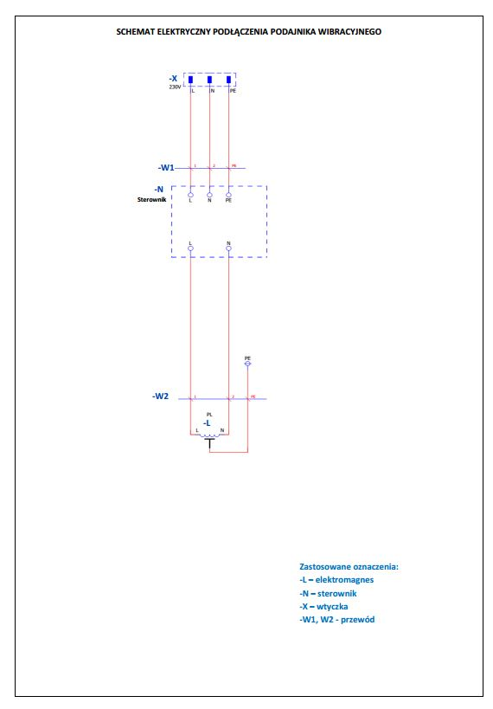

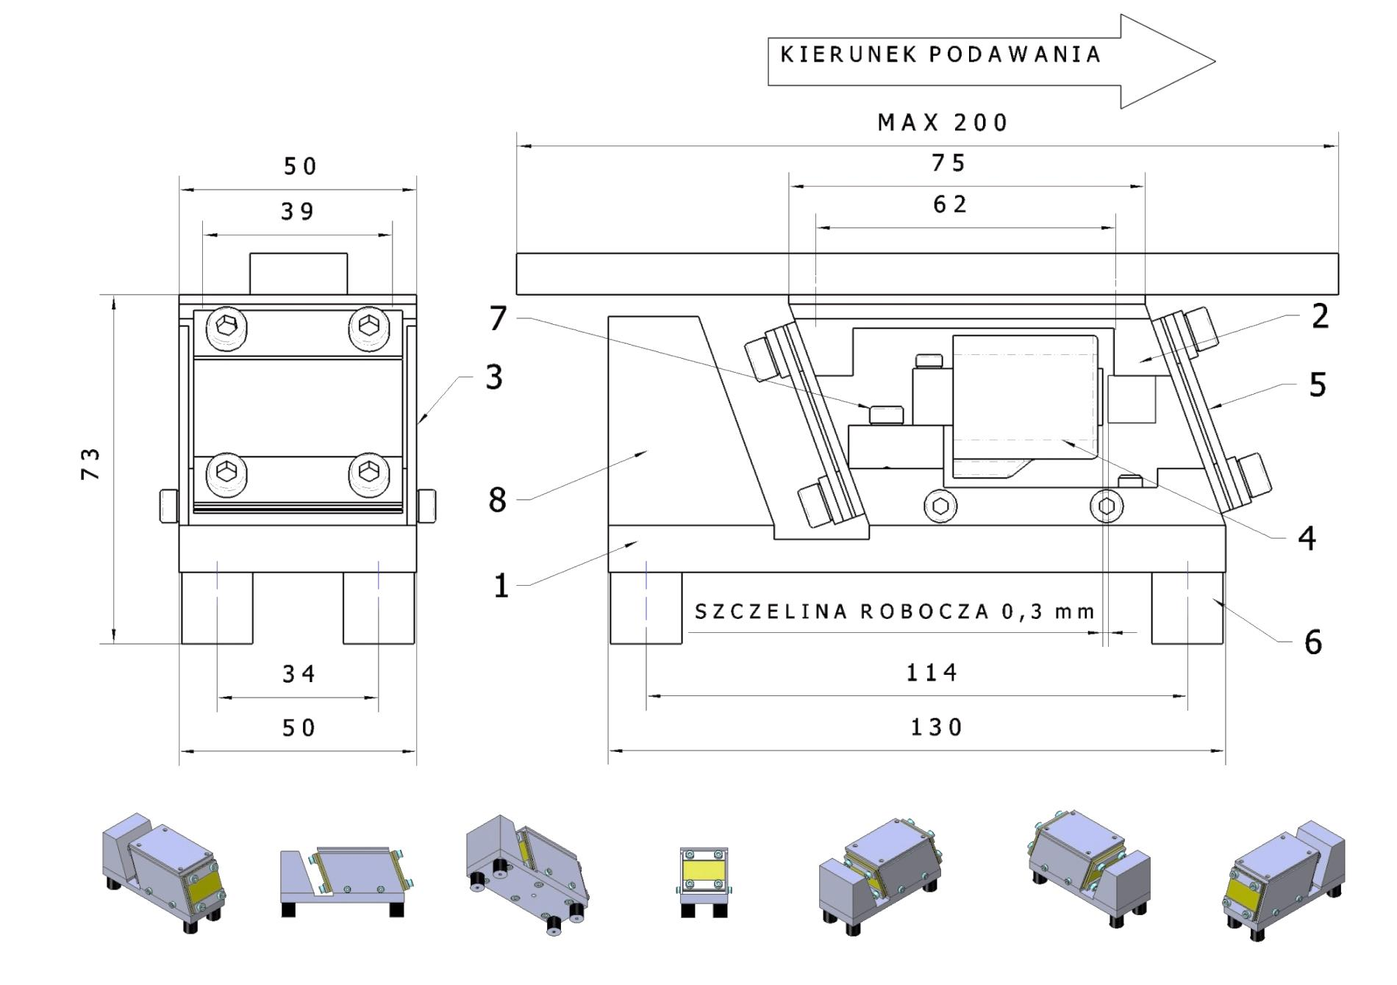

## **drawing 1.** Linear feeder type PL 1.

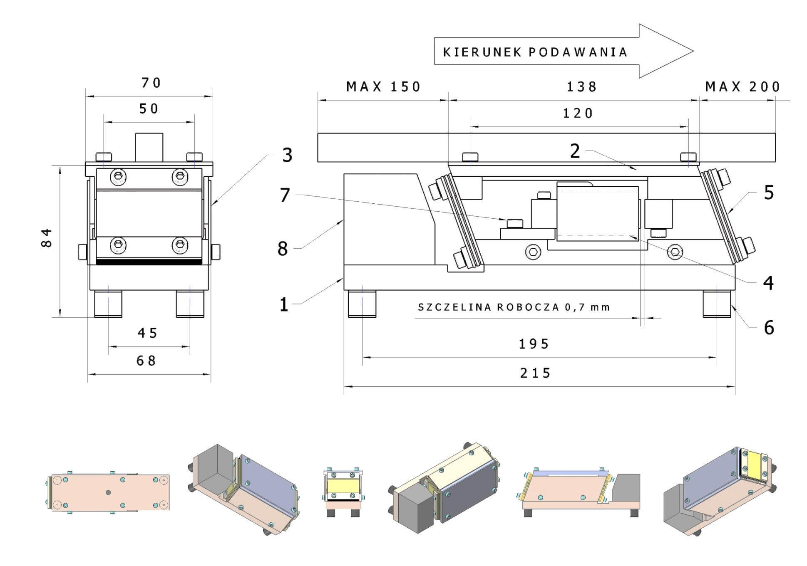

## **drawing 2.** Linear feeder type PL 2.

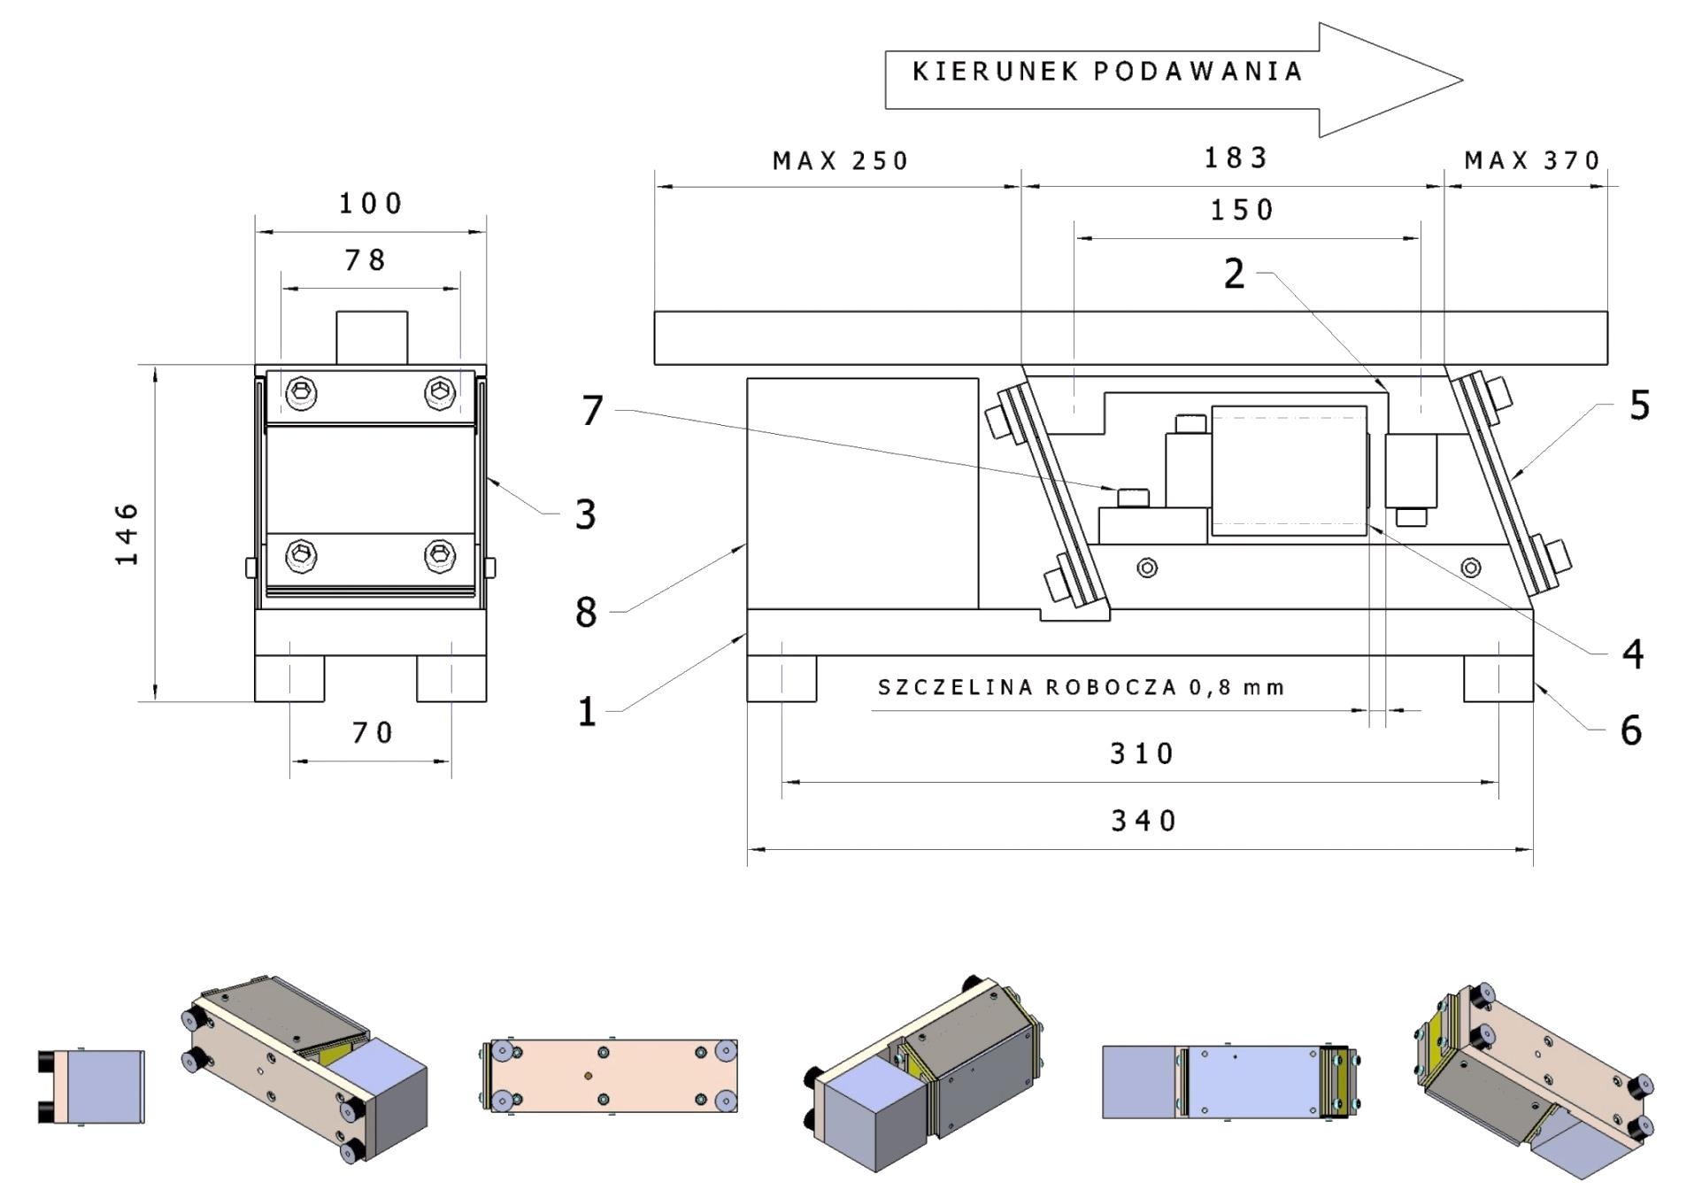

## **drawing 3.** Linear feeder type PL 3.